More about PunchList HandiWorks Cargo Drawers.

To make it much easier to load and unload partially accessible areas of many vehicles, we offer Cargo Drawers.

Below are pics of a Cargo Drawer we designed, built, and installed for a mid-sized van with very difficult access to the middle area. First with the empty drawer fully closed…
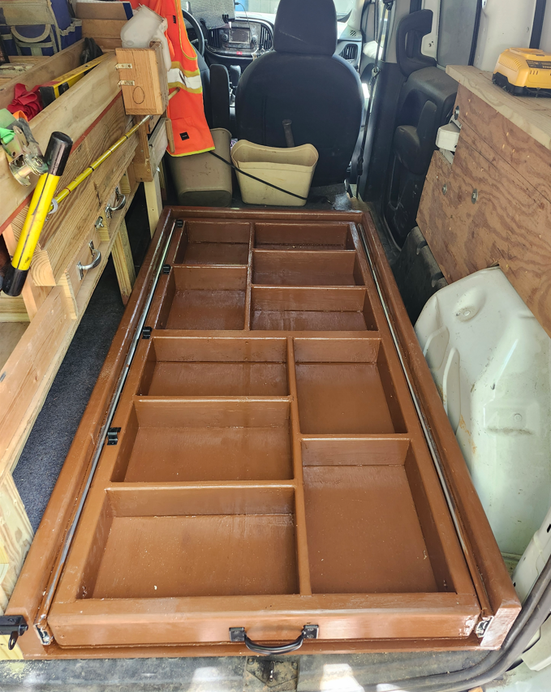…
…and next with the empty drawer fully withdrawn…
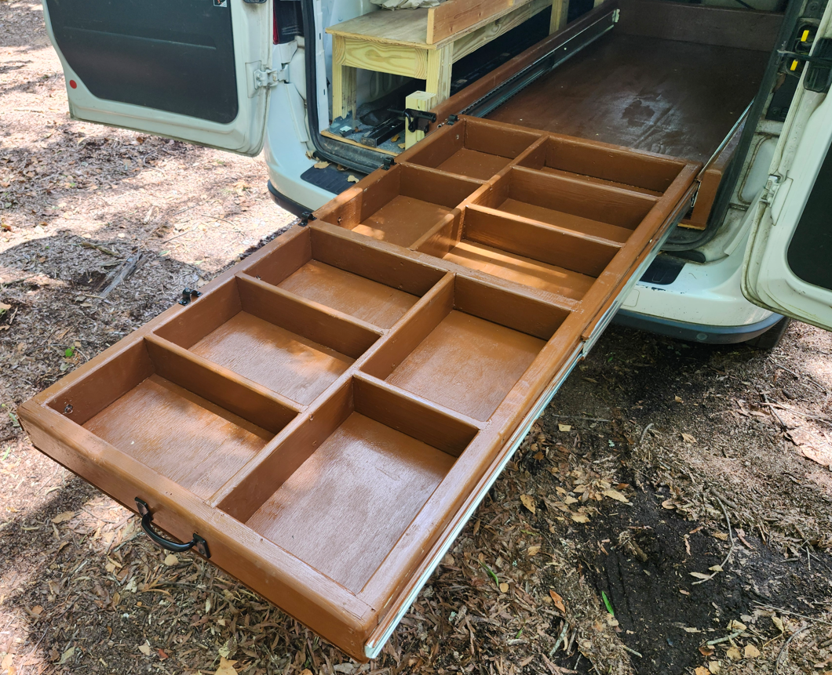

The next picture shows the Cargo Drawer fully extended out and loaded with groceries…
…
…and next it is securely back inside the van…
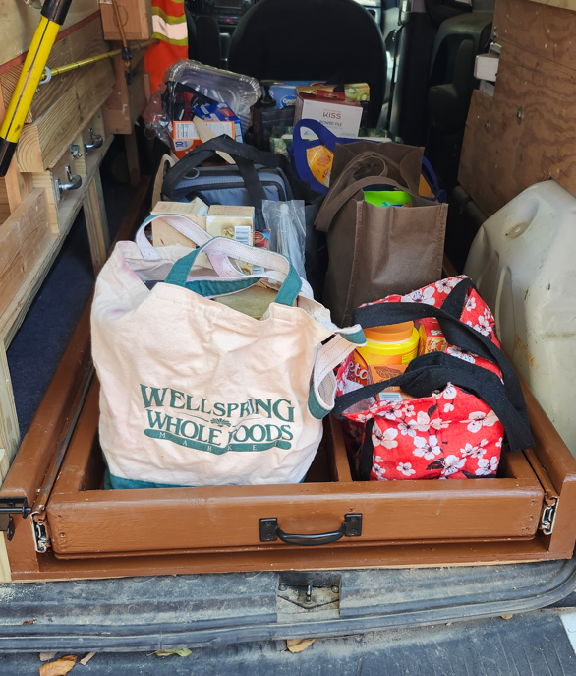
…with the load of Groceries.

If you take look back at the pictures above with the Cargo Drawer fully extended outward, you can appreciate how all portions of it are easily accessible with no arm-reaching, leaning, bending, or stretching. Our limited mobility clients feel as though this is the most important benefit of having a Cargo Drawer.

As with most of our products, Cargo Drawers are not one-size-fits-all items. Far from it. We’ll gladly design, build, and install one for you that meets your specific needs.

